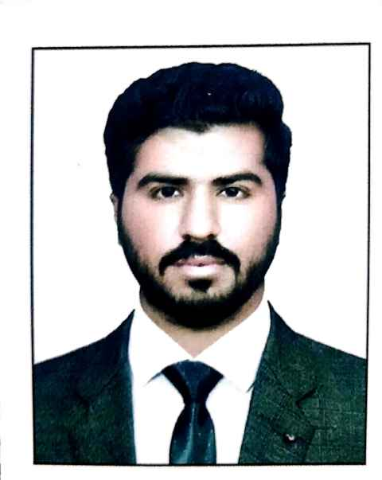


Najamuddin Bhurgri

Address: Village Thalho city khairpur Nathan shah district dadu


Mobile: +923110081030

E-mail: nawabnajam7@gmail.com

 Personal Profile
- Father’s Name : Sanaullah
- Surname : Bhurgri
- Date of Birth : 02-06-2002
- CNIC : 41203-4430651-1
- Domicile PRC : Dadu
- Religion : Islam
- Nationality : Pakistan
- Marital Status : Single


Education

Degree | Grade /CGPA | Board/University
BS(SOCIAL SCIENCE | 3.16 | University of Sindh Jamshoro
B.COM | 1ST DIVISION | Shaheed benazir bhutto university nawabshah
Intermediate | B | Bise Larkana
Matriculation | B | Bise Larkana



Job Experience

- I have done 3 Month intern-ship with FRDP NGOs under the project (urban food production)as social mobilizer at Hyderabad and wash project in Tharparkar Mithi.
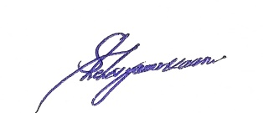
- Working as Customer Relationship officer Halan Microfinance Bank

